# Top 15 Luxury watches that command respect

## Introduction

We all know that the best watches are the ones that command respect. That's why we've compiled this list of luxury watches that will make you feel like a rock star every time you strap them on. From classic designs to cutting-edge machines, these are the watches we consider must-haves in any collection.

## IWC Portofino

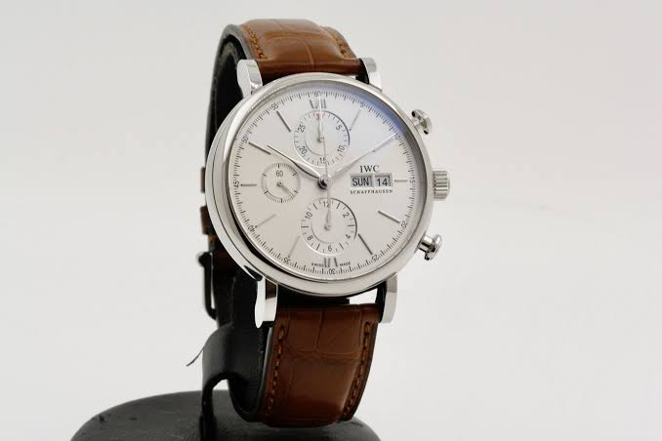

The IWC Portofino is a watch that commands respect. It has an automatic movement, water resistance to 100 meters, 42mm case diameter and date display. The dial features roman numerals in silver with luminous hands and markers. Rose gold plated bezel surrounds the case with rose gold plating on top of it as well.

The case back is engraved with the IWC Big Pilot logo and has a sapphire crystal caseback window. The strap is made of calfskin leather and has quick release pins so you can easily swap out different straps if you want to without having to take it to a watchmaker.

This is a great watch for someone who wants something that looks good, but also wants something that they can wear while they go out and do things. It’s got a classic look that would be perfect for a formal dinner or even just going out to dinner with friends.

The watch is made of 316L stainless steel and has a sapphire crystal caseback window. The strap is made of leather with quick release pins so you can easily swap out different straps if you want to without having to take it to a watchmaker.

## Cartier Tank

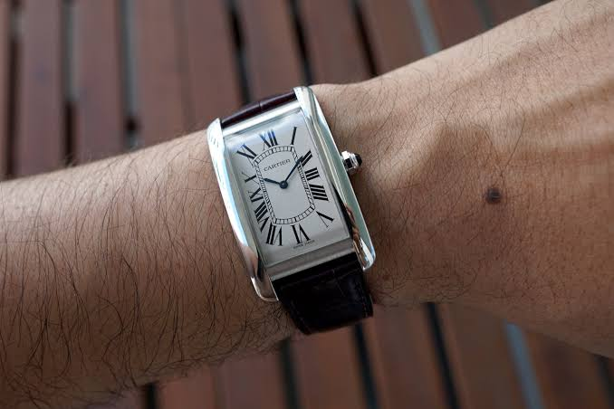

Cartier Tank

The Cartier Tank Francaise is an iconic luxury watch that has been around since 1943. It was created by Louis Cartier, who also designed the famous Patek Philippe Nautilus and Omega Constellation. The design of this watch has been copied by many other brands including Rolex, Vacheron Constantin and Longines (among others). This model has a two-piece case made from stainless steel with a bezel set with diamonds in 18 carat white gold or rose gold setting.

The case measures 29mm in diameter x 10mm tall at its highest point while maintaining an overall thickness of only 8mm along its sides due to its rounded shape being accentuated through rounding out both ends where they meet together forming what appears like an oval shape when viewed head-on instead of rectangularly like most other watches do except perhaps some Breitling models which also have similar designs but lack lugs which means there's no need for extra material outside either end which makes them thinner overall than their counterparts do because they don't have anything hanging off those sides either way around so if anything needs attaching onto another piece then it'll always be easier done inside rather than outwards towards another object.

## Rolex Cosmograph Daytona

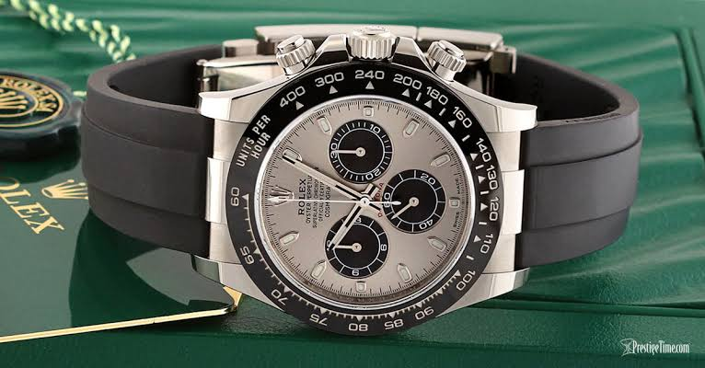

If you're looking for a watch that commands respect, then the Rolex Cosmograph Daytona is your answer. It's a luxury sports watch that has been around since 1955 and has become one of the most popular watches in history.

The first thing people notice when they see a Rolex Daytona? The price tag: $20,000 USD (or more). That's right—if you want to buy one today, it'll cost you more than $20k! But don't worry—if you can afford it (and your bank account can handle it), this watch will last forever because its parts are made by Rolex themselves with Swiss precision and craftsmanship. And no matter how much time passes between now and when they stop making this kind of thing anymore...they will always be there waiting for someone who wants their own piece from their collection before anyone else does!

## Jaeger-LeCoultre Reverso

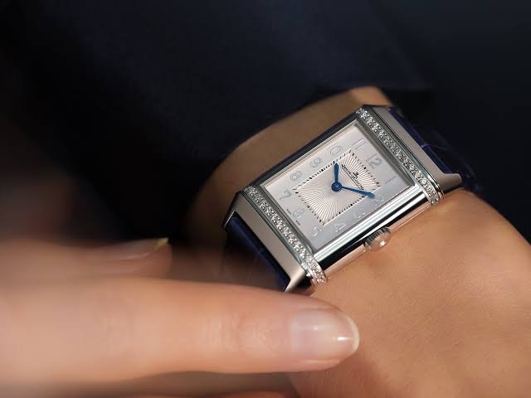

The Jaeger-LeCoultre Reverso is a classic watch that has been around for decades. While its design has changed over time, the watch is still elegant and functional. It also has a long history and is one of the most sought-after wristwatches today.

The watch was first created in 1933 by Georges Favre Leuba (1881–1943), who was head designer at Jaeger-LeCoultre at the time—and he used it as inspiration for other iconic designs like their Jetmaster (a self-winding chronograph). The name Reverso means “backwards” in French; this refers to how turning counterclockwise reveals another face on your dial!

As if this wasn't already impressive enough: if you want something unique enough but also timelessly stylish? This might just be what you've been waiting for!

## Rolex GMT Master II

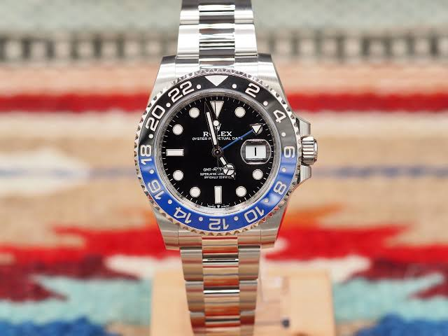

The Rolex GMT Master II is one of the best watches in the world. It's a classic, but also one of the most expensive at $54,000. The reason for its high price is that it has been made by hand since 1952 and has been used by many famous people including Fidel Castro, Steven Spielberg and Jeff Bezos (who owns Amazon).

The first thing you'll notice about this watch when you look at it is its incredibly large face (41mm across) with lots of numbers and hands around it that tell you time as well as date (and sometimes even moon phase). The second thing is how beautiful it looks; even though it's made from steel with a stainless steel band there are no plastic parts anywhere on this watch because everything else has to be made from scratch - so each part was hand-made by someone skilled enough to do so!

## Audemars Piguet Royal Oak

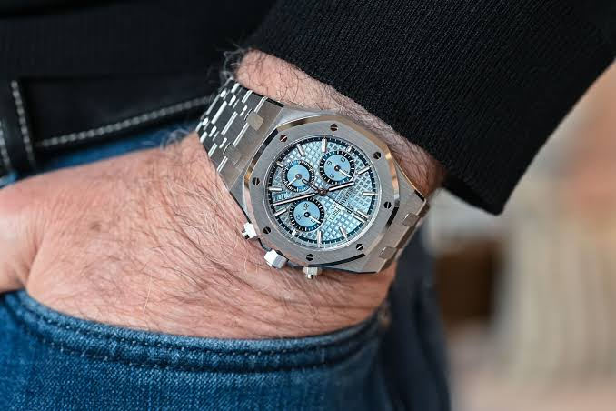

The Audemars Piguet Royal Oak is a watch that commands respect. It has been around since 1975, and it’s still considered one of the most sophisticated watches in its class today. This luxury timepiece was designed by Breguet and has been produced by them since then.

The Royal Oak lends itself to many different looks and styles, but it can be worn with any outfit you choose! If you like wearing bold colors or prints, this watch might be for you—it’s available in both steel and gold cases as well as leather strap options at various price points (from $5k-$22k).

You may opt for something more understated if you prefer something that blends into the background instead of standing out loudly like some other models might do; however, don't forget about those rare occasions where bold is absolutely necessary: weddings! For example...

## Chopard Mille Miglia GT XL Chrono Speed Black

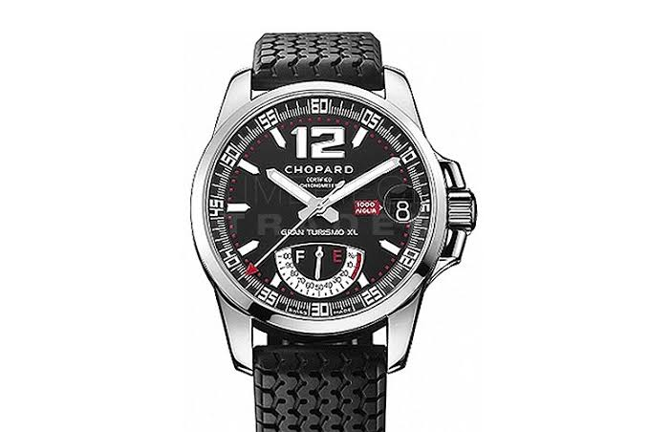

The Chopard Mille Miglia GT XL Chrono Speed Black is a Swiss luxury watchmaker that was founded in 1860. Today, it is one of the oldest watchmakers in Switzerland—and its watches are used by presidents and prime ministers alike.

The first thing you'll notice about this timepiece is its bold red dial (which matches perfectly with the case) and black leather strap. It also comes with an automatic movement that powers up to 40 hours per charge (though I've heard people say they last even longer). If you're looking for something bolder than regular black leather straps, then this watch would be perfect for you!

## Blancpain Fifty Fathoms Automatique 5015-11C40-O52A

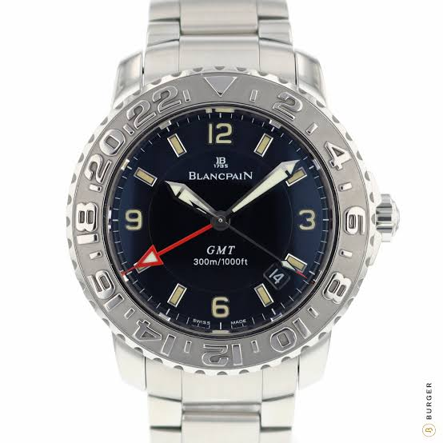

This watch is made of stainless steel, which means that it won't rust or corrode. It's also water resistant to 300 meters (1,000 feet). It has a skeletonized dial and an automatic movement. The caseback is sapphire crystal, so you can see the movement in action as you wear it—no more guessing what time it is!

The Fifty Fathoms Automatique 5015-11C40-O52A by Blancpain will set you back $3200 USD on Amazon right now—but if you have that kind of cash lying around, we'd say it's worth every penny.

## Omega Seamaster Planet Ocean Big Size 600m Co Axial Chronometer Mens Wristwatch

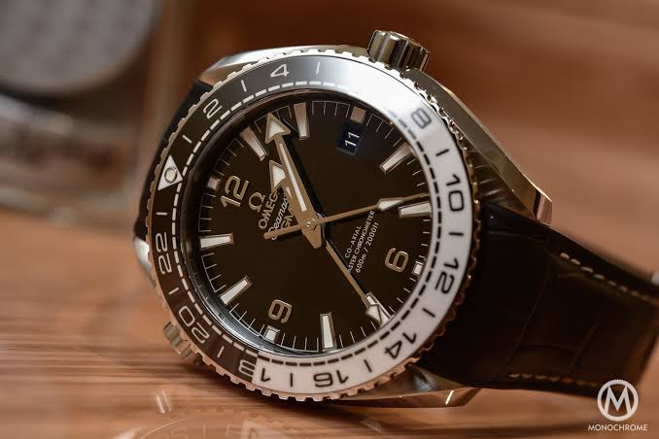

This watch is not only waterproof, but also has a water resistant to 600 meters. It has chronograph movement and date display. The white dial with blue accents make it look very elegant and stylish. The bezel is made of blue ceramic, which makes this watch more attractive than other models in the market that are made from steel or titanium.

## Vacheron Constantin Metiers d'Art Geneve

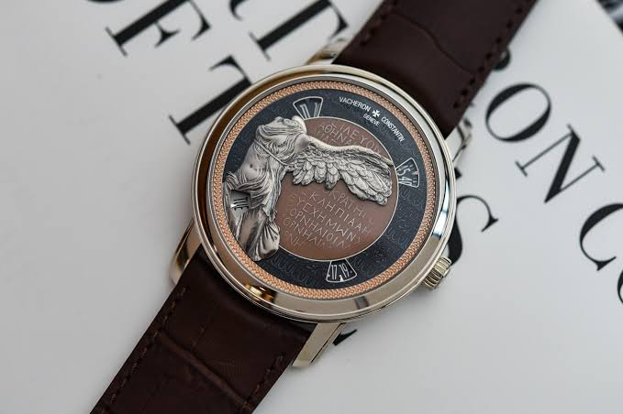

The Vacheron Constantin Metiers d'Art Geneve is a limited edition watch with a hand-made and gold plated dial. This luxury watch comes with diamonds on the face and comes with an automatic movement.

This luxury watch has been made in Switzerland, meaning that it's made to last forever and will never need to be serviced by anyone but the original manufacturer.

## Patek Philippe Nautilus Men's Watch 5711/1A-010

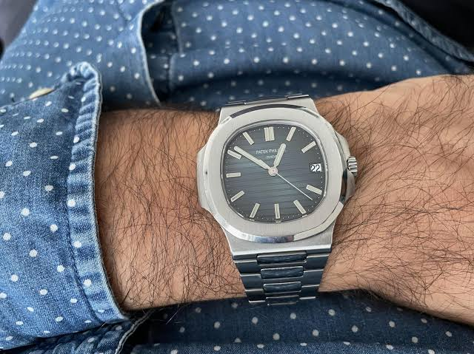

The Patek Philippe Nautilus Men's Watch 5711/1A-010 is a rose gold case and bracelet watch that measures 40 mm in diameter. It has an automatic movement with date display, water resistance up to 120 meters (393 feet), and it comes with a black leather strap.

## Ulysse Nardin Dual Time Two Time Zone Rose Gold Watch on Strap 243-22/60

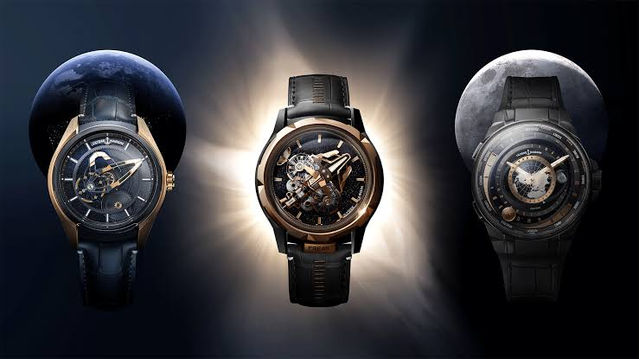

The Ulysse Nardin Dual Time Two Time Zone Rose Gold Watch on Strap 243-22/60 is a watch that will surely make you stand out from the crowd. It's made of rose gold and has a rubber strap, which is definitely a plus. The case itself measures just under 40mm in diameter, so it's not too big or too small—it fits comfortably under your arm when you're wearing your suit jacket or sweater (or both).

The first thing that catches my eye about this timepiece is its unusual design: there are two main sections to consider here—the top half has an hour display while the bottom half has a minute display; these two displays can be used simultaneously! But wait! There's more! If you want to keep track of your power reserve indicator as well as date information at once, simply press down both sides together for quick access because they're pretty close together anyway!

## Fine watches are a mark of success and luxury.

You’re reading this, so you know what fine watches are all about. The best way to describe a fine watch is that it commands respect. A man with an expensive watch on his wrist is considered more successful than one who has not. A woman with an expensive watch on her wrist is considered more successful than one who does not have one. However, there are some people who believe that having a nice watch won't get them anywhere—these people aren't interested in getting anywhere; they're just looking for something to put on their wrists!

Whether it's used as collateral or collateralized debt obligations (CDOs), there are many different ways that watches can be used as investments and even income streams:

## Conclusion

There you have it. The best luxury watches that command respect. They are all very high-quality, and they will last forever if cared for properly. We hope this article has helped you understand why these watches are so valuable, as well as what makes them so special!